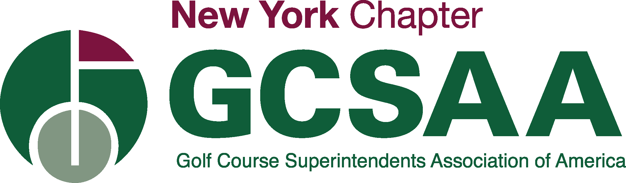
Great Lakes Turf School
Tuition Reimbursement Program
- Purpose:
To provide tuition reimbursement to a current or future student at the Great Lakes Turf School who is a current member of GCSA of NY or sponsored by a current GCSA of NY member.

- Tuition Reimbursement Awards:
- The scholarship committee will choose the recipients of the tuition reimbursement program based upon the information provided.
- An applicant can only receive one scholarship.

- Eligibility:
- Applicant must be a current GCSA of NY member or sponsored by a current GCSA of NY member
- Must provide a Certificate of Completion from the Great Lakes Turf School.
- Must provide proof of payment with the amount and date of tuition paid.
- A typed letter of recommendation from an employer or sponsor.
- A one-page statement describing why you wanted to take this course and how taking this course has or will benefit you in your future endeavors.

- Basis for Selection:
- Applications and supporting documentation must be sent to the Chapter Administrator who will then forward to the Scholarship Committee without name and address of applicant. Only applications that include all the supporting information will be forwarded to the reviewing committee. The committee will then review the information and select the winner/winners based upon the information submitted.

Contact Information:
Name ________________________________________________________________________________________
Permanent Address _____________________________________________________________________________
City _______________________________________________State ______________ Zip____________________
Organization _________________________________________________________________________________
Telephone____________________________________________________________________________________
Email_______________________________________________________________________________________

Applications and supporting documentation must be mailed to:
GCSA of NY
P.O. Box 70
Camillus, NY 133031
Or email to gcsaofny@gmail.com

